**Agent Services**

*Коммент* [*Ivan Sokolov*](mailto:i.sokolov@symfa.com) *после встречи 9/25:*

Изначально напутал с проектом DMZ. Думал, что DMZ - это отдельный проект

DMZ – это часть другого проекта [**TransCredit - Certificates**](https://docs.google.com/document/d/1xr9AWedDZbjjojUxT805tWm3HxfA-igylEE8mQaUUNc/edit?tab=t.0)

Здесь же ниже пойдёт речь об `Agent Servicies` – отдельной большой инициативе

Этот проект нацелен на автоматизацию процесса актуализации данных об агентах.  
Текущий процесс супер-ручной и очень подвержен человеческому фактору

Стек: HTML(!) + C#

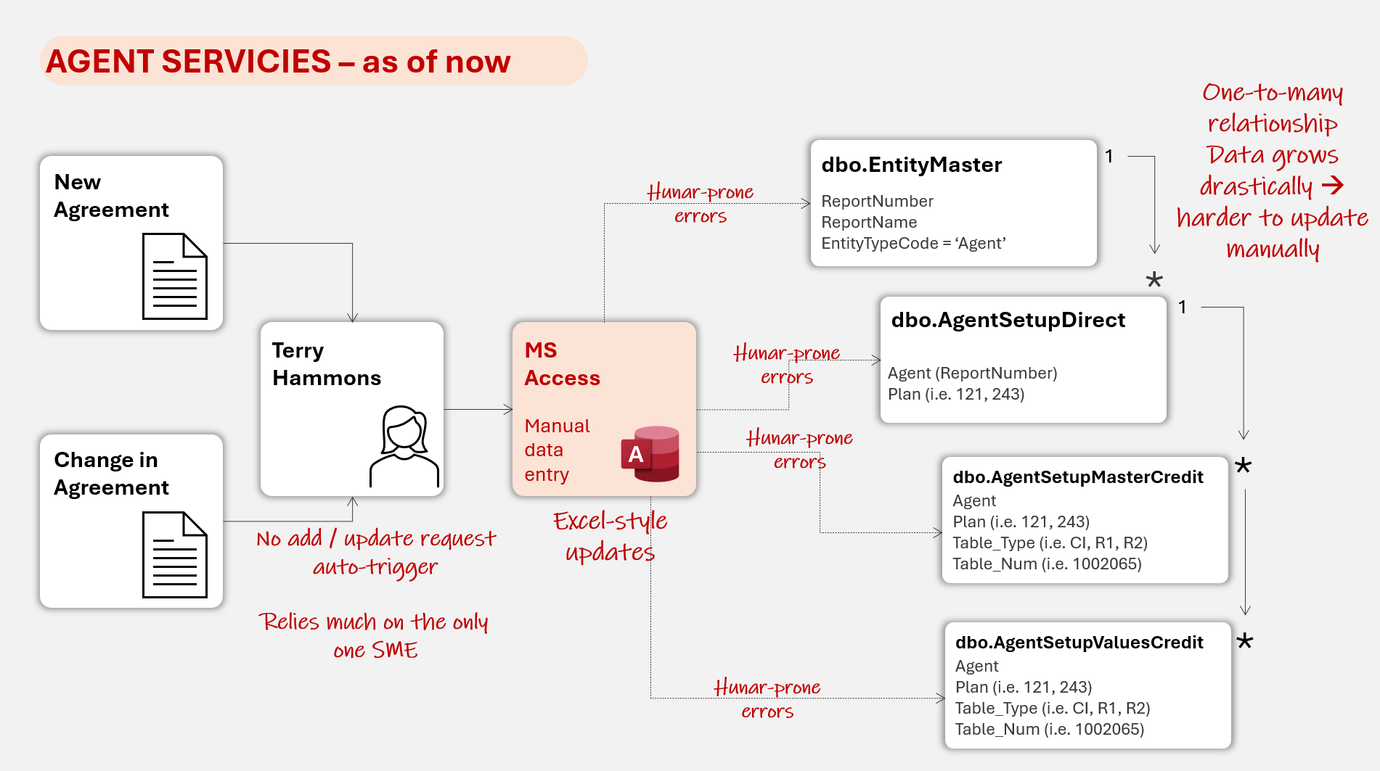

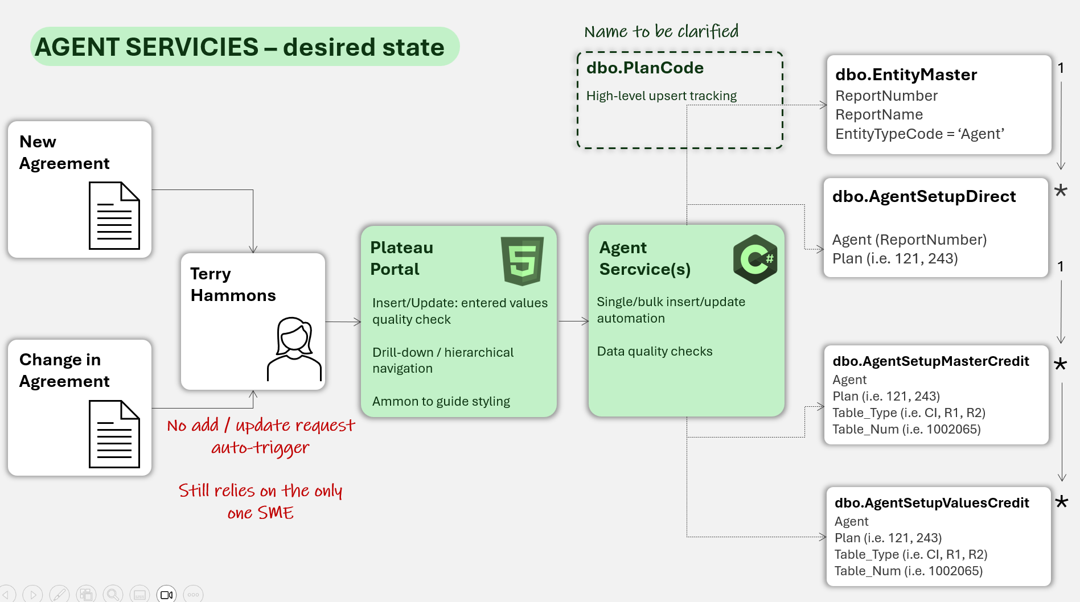

*Оригинальный текст от Аммона:*

Agents are the individual locations that sell our products. New agents are brought on all the time, and existing agents have their information updated frequently. Agents also have settings that determine which products (aka plans) they can offer, and many different settings for those products (reinsurance, risk codes, etc).

Currently all editing of this data is done through direct database tables in Access. We need to move these features to a web interface under PlateauGroup.Web -> Components/Pages/Agent/

Agents are stored in the EntityMaster table, with EntityTypeCode 'Agent'

Key Tables:

AgentSetupDirect - indicates which plans (aka product) an Agent can sell

AgentSetupMasterCredit - Links each Agent and a plan to a table, depending on the table type (commission, reinsurance, risk amount, etc)

AgentSetupValuesCredit - Detailed table with values for different durations (liked to agentSetupMasterCredit Table_Num above, with duration from 0-100 in years)

Because a customer can have multiple agents (ie locations/buildings), and many agents are similar to each other, we need a way to quickly and easily apply updates and copy values between agents. Below are some of the known ways data needs to be copyable and editable for an agent:

EntityMaster:

* + Add/Edit Agent information
    - Copy Values popup
      * Allow search / selection of another agent to copy
      * Show selection of fields to copy (all by default)
  + Add Agent w/copy
    - Search / select another agent to copy from
    - Enter new name
  + Bulk Edit Agents
    - Select by Marketing Rep or Customer Number, or TPA Number
    - Allow editing of common fields for all selected agents

* + **Other Tables:**
    1. Plan Code Add/Edit control
    2. Plan Code Add/Edit popup
    3. Plan Code List control (for agent)
       1. Plan Code List popup, allow selection (return selected codes)
    4. Bulk Edit of Plan Codes
       1. Show Plan Code Add/Edit popup
       2. Edit will save changes to ALL selected plan codes
    5. Bulk Plan Code Copy
       1. Agent search and selection
       2. Show selected agent's plan code list control (with selection)
       3. Copy all plan codes from agent to the other
    6. Add simple PlanCode audit log for general changes (not details of every record)

*** If changing risk form, show popup, ask if they want to flat cancel/reissue all certs for the changes to take effect (if there are any certs with the editing plans)

** Never remove from Agent Setup Direct!!!! (agent setup master credit is okay) **